Lab experiment
4.Create a Scrum Project in Jira.
• Add a backlog with at least 5 items (e.g., "Create user
registration page", "Develop API for login").
• Prioritize the backlog and create a 1-week sprint.
• Move backlog items into the sprint and start the sprint.
• Finally show the Screenshot of the sprint board at the start and
end of the sprint.

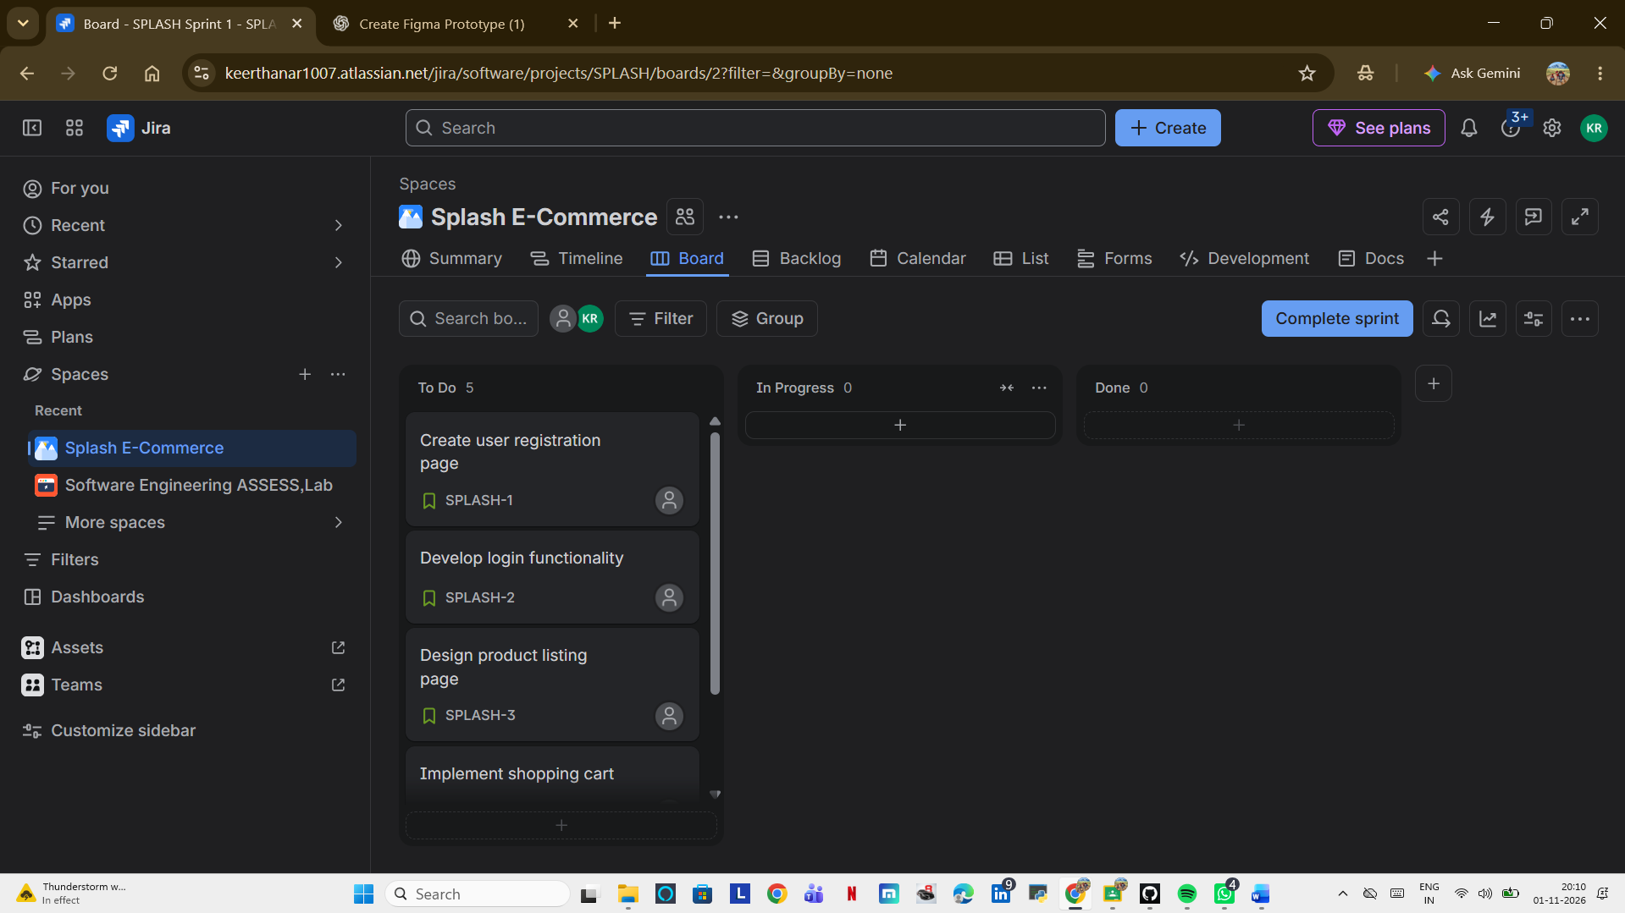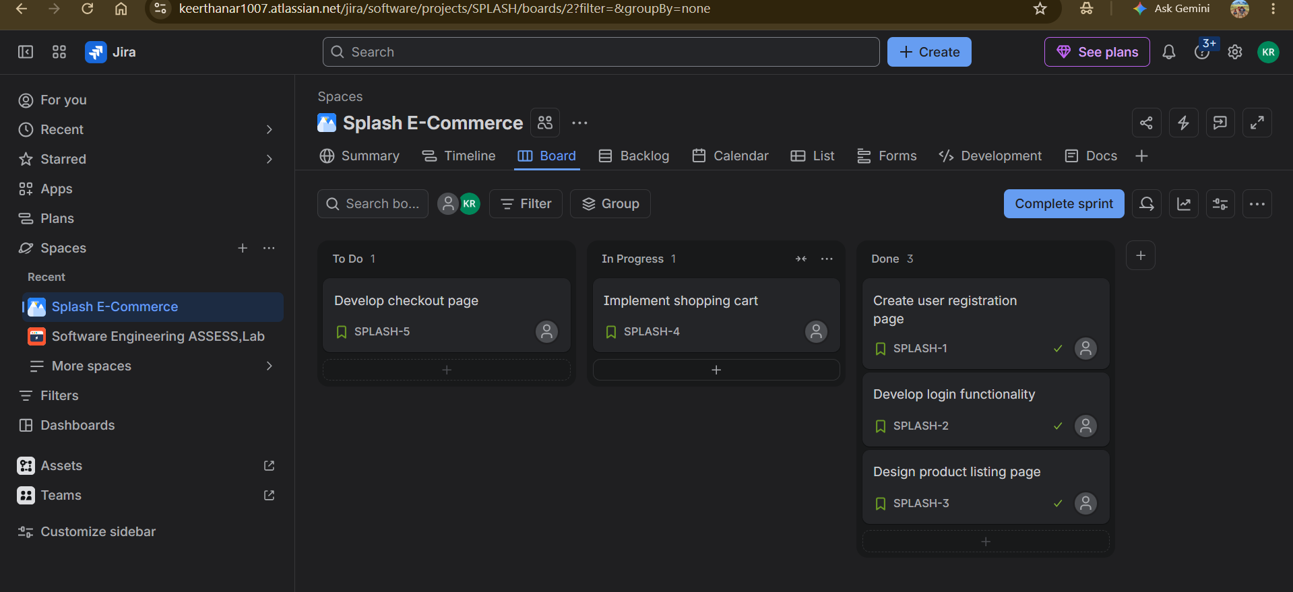https://keerthanar1007.atlassian.net/?continue=https%3A%2F%2Fkeerthanar1007.atlassian.net%2Fwelcome%2Fsoftware%3FprojectId%3D10001&atlOrigin=eyJpIjoiY2Y1NjZmNzQ0NGNjNDA4M2I0ZDdlOTAwMmRiMWUyMzIiLCJwIjoiamlyYS1zb2Z0d2FyZSJ9

